Gemini Resume generator based on Job Description
Status: Highly Feasible
Building a dynamic resume updater is a logical evolution from a QnA chatbot. You are moving from basic retrieval to extraction, comparison, and structured generation. Given your work with the Gemini Flash model, the architecture is entirely supported by the API's current capabilities.
System Architecture
The pipeline requires three primary stages to move from unstructured text to a formatted document.
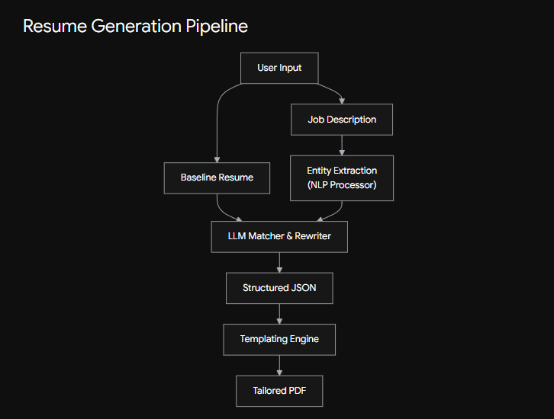
Why Gemini Flash is Suited for This
- Native Document Understanding: You don't need a separate OCR or parsing pipeline. You can pass your resume PDF and the job description directly into the model's context window. Flash handles up to 1 million tokens natively.
- Structured Output (JSON Schema): This is the critical feature for this project. Instead of asking the model to "rewrite the resume" and hoping the text format doesn't break, you can enforce a strict JSON output using Pydantic models. You define the exact schema (e.g., experience, skills, projects), and the API guarantees the output matches it.
- Speed and Cost: Flash is optimized for high-volume, low-latency tasks, making it ideal for iterative prompt chains (e.g., processing your experience blocks one by one).
Implementation Strategy
Instead of a single zero-shot prompt, a robust pipeline requires a chained approach:
- Entity Extraction: Pass the job description to the model and enforce a JSON schema to extract required_skills, core_responsibilities, and domain_knowledge.
- Impact Alignment: Pass your baseline master resume and the extracted job entities to the model. Prompt it to rewrite your bullet points.
Crucial prompt instruction: "Do not invent experience. Only reframe existing facts to highlight overlap with the required skills."
- Document Compilation: Once you receive the updated JSON payload from the model, use a templating engine (like Jinja2) to inject the data into a LaTeX or Markdown template, then compile it to a final PDF.
Potential Roadblocks & Mitigations
Risk | Mitigation
Hallucinations | The model might invent skills you don't possess to match the job description. Strict system prompts and low temperature settings (e.g., 0.1) are mandatory.
Formatting Loss | LLMs struggle to maintain precise spatial formatting (like margins and columns). Always output raw data (JSON) and handle the presentation layer in your code.
Context Overwriting | If you update a previously tailored resume, you lose your complete baseline history. Always use a "master resume" containing every project and role as the source of truth for the model to pull from.

